SWOT Analysis Supporting Facebook

iRobot
Prepared by: Seth Ricks
Date: 8/22/2025

SWOT Diagram
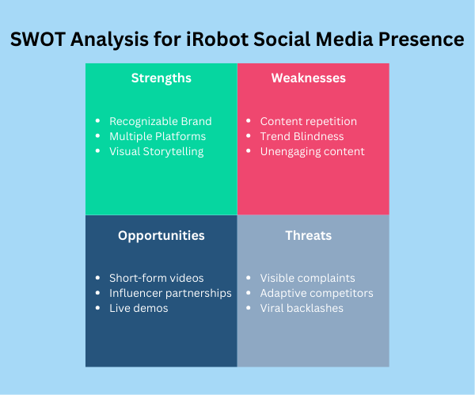

SWOT Outline
Thesis Statement:
iRobot has a presence on several social media platforms, but the one that needs the most improvement is Facebook. Many Millennials and Gen-Z’s use Facebook and are the ones that are disapproving of iRobot on their page. A SWOT Outline of iRobot’s Facebook presence is given below.
- Strengths
  - Recognizable Brand: iRobot is easily recognized as the creator of Roomba.
  - Multiple Platforms: iRobot is present on Twitter, Instagram, and Facebook.
  - Visual Storytelling: iRobot’s Facebook page tells visual stories of people enjoying their product.
- Weaknesses
  - Content repetition: iRobot’s content on Facebook is repetitive and may lose user interest over time.
  - Trend Blindness: The page doesn’t take advantage of current viral trends or ‘meme’ templates, which their target audience is accustomed to.
  - Unengaging content: The Facebook page content is long, boring, and unengaging. It is easy to lose interest quickly.
- Opportunities
  - Short-form videos: People of all ages are now accustomed to short-form content, such as short reels and videos.
  - Influencer partnerships: Many people will listen to a celebrity they like or follow.
  - Live demos: Demonstrating the product live, possibly with an influencer, could boost user numbers.
- Threats
  - Visible complaints: Almost all the posts on Facebook page have comments with complaints about iRobot’s products and customer service.
  - Adaptive competitors: Comparing iRobot’s Facebook page with Shark’s (one of their competitors) it is obvious that Shark cares more about making interesting content.
  - Viral backlashes: Simply looking up ‘Viral Backlash Roomba Facebook’ on a web browser shows all the problems that iRobot has been dealing with, such as security and privacy issues.
Conclusion:
iRobot can improve its social media platforms, Facebook in particular. While their page has some strengths, they are not reacting appropriately to what social media users are accustomed to. They are also not keeping up with their competitors’ content. It is almost like social media is working against them.

